Last Minute CLE Watch Party  December 29, 2022  Total Credits: 5 Dual  Description: We will be showing 5 dual (ethics) hours of our most popular CLE online videos on the big screen to get you through that last 2022 hump. |  | 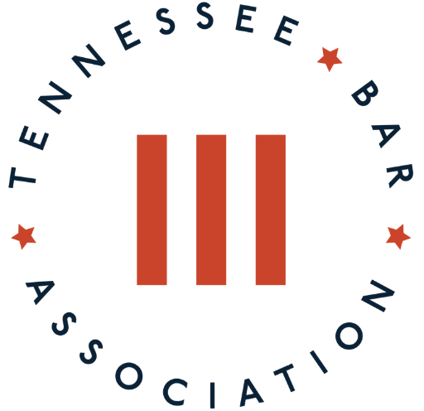
10 a.m. – 11 a.m.  DUAL | Bill and Phil Show  Don't miss this annual staple! Attorney Bill Ramsey and legal technologist Phil Hampton share a broad overview of the latest tech gadgets, apps, tools, and tips for attorneys.
11:05 a.m – 12:05 p.m.  DUAL | Essential Presentation Skills for Attorneys  In this on demand workshop, you’ll learn how to sharpen your message; engage your audience; master the virtual presentation, including technology tools, lighting and set-up; and use voice, gestures and eye contact to speak effectively.
12:10 – 1:10 p.m.  DUAL | Ethics Update: Current Developments from the Board of Professional Responsibility  Join the Board of Professional Responsibility's Eileen Burkhalter Smith as she reviews the latest Ethics Updates.
1:15 – 2:15 p.m.  DUAL | Killer Correspondence  One of the sharpest tools in the lawyer’s arsenal is a surprisingly common item: the letter. Whether it’s a demand letter, a note sent during negotiations, or a client communication, a lawyer’s success could be dependent on a piece of correspondence. Join the CLE Performer, Stuart Teicher as he explains how to write a variety of effective legal letter types.
2:15 – 3:15 p.m.  DUAL | How to Take Charge of Technology Ethically & Mindfully  Join attorneys Becky Howlett and Cindy Sharp, as they present their latest class with strategies designed to help attorneys manage and even unplug from the digital world - ethically and mindfully.

