TBA Court Square Series: Murfreesboro  May 17, 2022 — Rutherford County Chamber of Commerce  Program Producer: Aimee Luna, Legal Aid Society of Middle Tennessee  Total Credits: 2 Dual, 1 General |  | 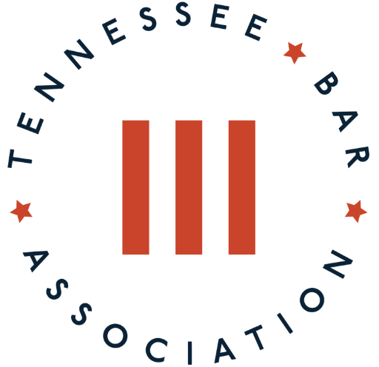
This three-hour program is designed to provide attorneys with the latest developments in multiple areas of the law. Kick off the afternoon with a lunch and learn networking session with TBA leadership and a much-needed attorney mental health session with Judge Toby Gilley of Rutherford County General Sessions Court Part III. Other timely topics include an essential family law session with Amelia Luna of the Legal Aid Society Of Middle Tennessee and an ethics update with Beverly Sharpe from the Board of Professional Responsibility.
11:30 a.m. – 12 p.m. CDT | Registration and TBA President Networking Lunch  (Lunch provided)
12 – 1 p.m.  DUAL | Dealing with Acute Mental Health Crisis: Rutherford County General Sessions Court Judge Toby Gilley  Judge Toby Gilley’s experience holding an involuntary commitment docket at the VA Hospital and Trustpoint Hospital will be the basis/background for this session; he will discuss the effects of Secondary Trauma and attorney well-being.  Judge Toby Gilley, Rutherford County General Sessions Court
1 – 1:10 p.m. | Break
1:10 – 2:10 p.m.  DUAL | Ethics Update: Current Developments from the Board of Professional Responsibility  This presentation will address recent disciplinary decisions and discipline imposed by the Board of Professional Responsibility and the Tennessee Supreme Court, applicable rule changes and other current ethical issues.  Beverly Sharpe, Tennessee Board of Professional Responsibility
2:10 – 2:15 p.m. | Break
2:15 – 3:15 p.m. | Family Law Essentials  This session will focus on keeping clients safe from domestic violence with Orders of Protection, as well as handling divorces for low-income clients using Affidavits of Indigency and Family Law resources available through the AOC.  Aimee Luna, Legal Aid Society of Middle Tennessee

